

ASSESSMENT TOOL 3 DEBUGGING & OPTIMISATION TASK

CSA0609-DESIGN AND ANALYSIS OF ALGORITHMS

Submitted by
S.SUDHARSAN (192421012)

Q34. Debugging Binary Search Code (Incorrect Mid Recalculation Logic)
Question
The following Binary Search code recalculates the midpoint incorrectly because the boundary updates are inconsistent with the search direction. Carefully inspect the update rules for low and high and explain why valid regions may be discarded. Debug the code step-by-step so that the search interval shrinks correctly in all cases. Optimize the implementation for clarity and proper handling of edge cases. Analyze best, average, and worst-case time complexity and rewrite the corrected code with suitable documentation.
def binary_search(arr, key):
low, high = 0, len(arr)-1
while low <= high:
mid = (low + high) // 2
if arr[mid] == key:
return mid
elif arr[mid] > key:
low = mid + 1 # ERROR
else:
high = mid - 1 # ERROR
return -1

STEP BY STEP ERROR ANALYSIS
STEP 01 : Incorrect Boundary Update
When arr[mid] > key, the algorithm should search in the left half.
Incorrect Code
low = mid + 1

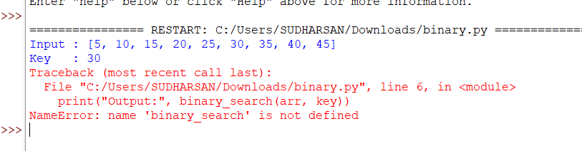

Problem
This moves the search to the right side and discards the left half where the key may actually exist.
STEP 02 : Wrong Search Direction
When arr[mid] < key, the algorithm should search in the right half.
Incorrect Code
high = mid – 1

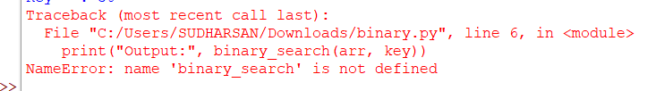

Problem
This moves the search to the left side instead of the right side, causing valid elements to be skipped
EFFECTS OF ERROR
- The search moves in the opposite direction.
- The correct search region is discarded.
- Existing elements may never be checked.
- The function returns -1 even when the key is present.
- Binary Search no longer works correctly.
CORRECT STEPS
- If arr[mid] > key, update
high = mid - 1
- If arr[mid] < key, update
low = mid + 1
- Continue until low > high.
- Return the index if the key is found.
- Otherwise return -1.
ALGORITHM
- Input the sorted array and search key.
- Initialize
low = 0
high = len(arr)-1
- Repeat while low <= high
- Find
mid = (low + high) // 2
- If arr[mid] == key, return mid.
- If arr[mid] > key, search left side by setting
high = mid - 1
- Otherwise search right side by setting
low = mid + 1
- If the loop ends, return -1.

MANUAL PROCESS
Array
[5, 10, 15, 20, 25, 30, 35, 40, 45]
Key = 30
Step 1
low = 0
high = 8

mid = (0 + 8) // 2
= 4
arr[4] = 25
Compare
30 > 25
Move to right side
low = 5
Step 2
low = 5
high = 8

mid = (5 + 8) // 2
= 6
arr[6] = 35
Compare
30 < 35
Move to left side
high = 5
Step 3
low = 5
high = 5

mid = (5 + 5) // 2
= 5
arr[5] = 30
Key Found
Return Index = 5
COMPLEXITIES
Best Case
Time Complexity
O(1)
Explanation
The key is found in the first comparison.

- Average Case
Time Complexity
O(log n)
Explanation
The search space is reduced to half during each iteration.
- Worst Case
Time Complexity
O(log n)
Explanation
The element is found after several comparisons or is not present.
- Space Complexity
O(1)
Only constant extra memory is used.

DEBUGGING SUMMARY
➤ Primary Flaw: Boundary updates were reversed.
➤ Failure Scenario: The search moves in the wrong direction and skips the correct region.
➤ Correct Fix: Use
high = mid - 1
when the middle element is greater than the key, and
low = mid + 1
when the middle element is smaller than the key.
➤ Overall Outcome: The search interval shrinks correctly, ensuring accurate and efficient searching.

PSEUDO CODE
FUNCTION BinarySearch(arr, key)

SET low = 0
SET high = length(arr) - 1

WHILE low <= high

SET mid = (low + high) // 2

IF arr[mid] == key THEN
RETURN mid

ELSE IF arr[mid] > key THEN
SET high = mid - 1

ELSE
SET low = mid + 1

END WHILE

RETURN -1

END FUNCTION

CORRECTED & OPTIMIZED IMPLEMENTATION
def binary_search(arr, key):
"""
Binary Search on a sorted array.
Returns the index of the key if found,
otherwise returns -1.
""" if not arr:
return -1
low = 0
high = len(arr) - 1
while low <= high:
mid = (low + high) // 2
if arr[mid] == key:
return mid
elif arr[mid] > key:
high = mid - 1 # Correct
else:
low = mid + 1 # Correct
return -1

DRIVER / TEST CODE
arr = [5, 10, 15, 20, 25, 30, 35, 40, 45]

key = 30
print("Input :", arr)
print("Key :", key)
print("Output:", binary_search(arr, key))

print("-" * 30)

key = 45
print("Input :", arr)
print("Key :", key)
print("Output:", binary_search(arr, key))

print("-" * 30)

key = 18
print("Input :", arr)
print("Key :", key)
print("Output:", binary_search(arr, key))

